**Name: Shihab Muhtasim**

**ID:21301610**

**CSE421 lab2**

**Task 1**

**HTTP REQUEST**

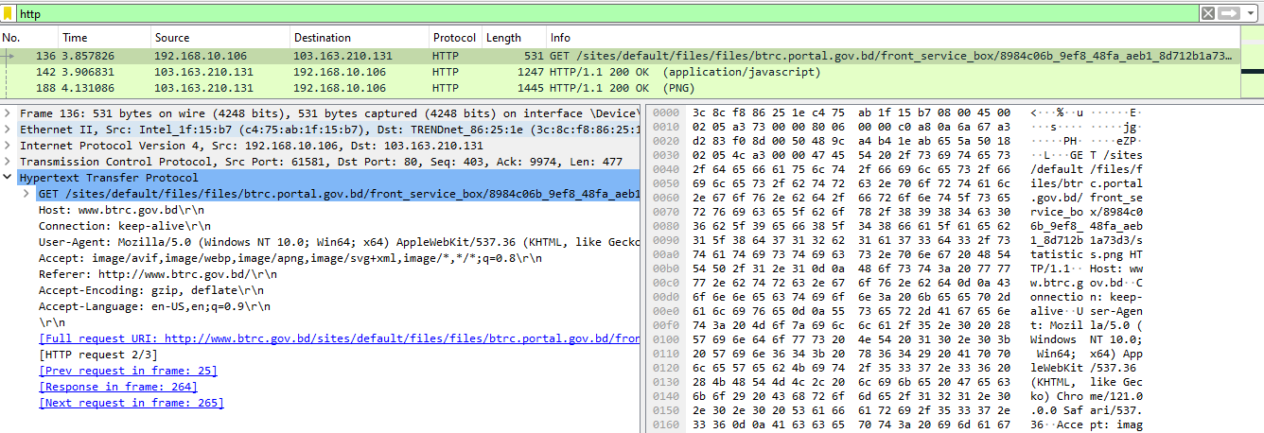

In this GET request, the source is my computer and the destination is the server (Host) of the website I’m trying to access. I sent a GET request to the server to access information. In the header of the application layer, we can see the types of data (image, text etc) that can be sent back to this request; the data language accepted; the website address; and the data encoding type.

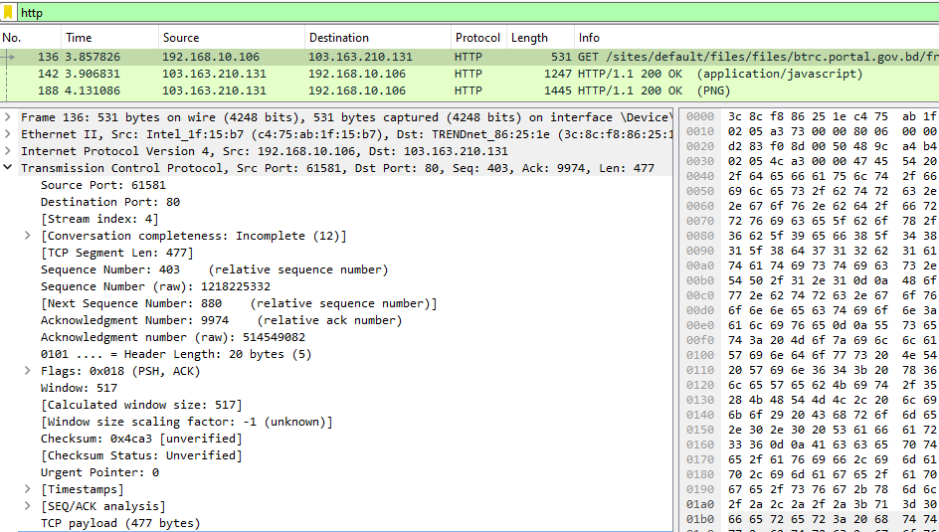

In the transport layer for port-to-port delivery, the source port is my port and the destination is the well-known port 80 to access the website. There are sequence and acknowledgment numbers for the receiver to understand the data segment numbers. There are PSH and ack flags. PSH flag is to signal that the data is to be sent out. URG is set to 0 as there is no urgent data request.

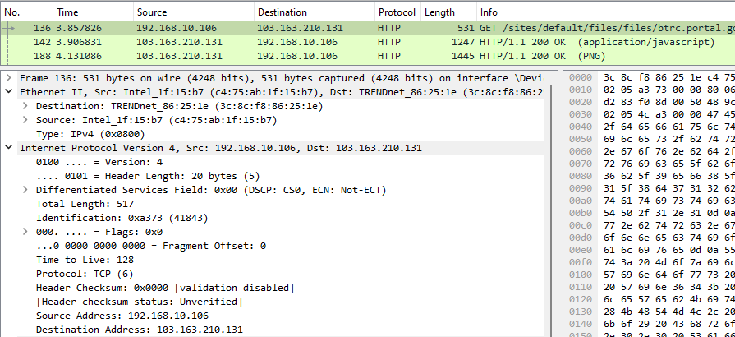

The network layer used the IPV4 and mentioned length, TCP protocol, checksum info, and socket information: source and destination IP address.

The Data link layer has the MAC addresses of the source device and the next destination’s MAC address.

**HTTP RESPONSE**

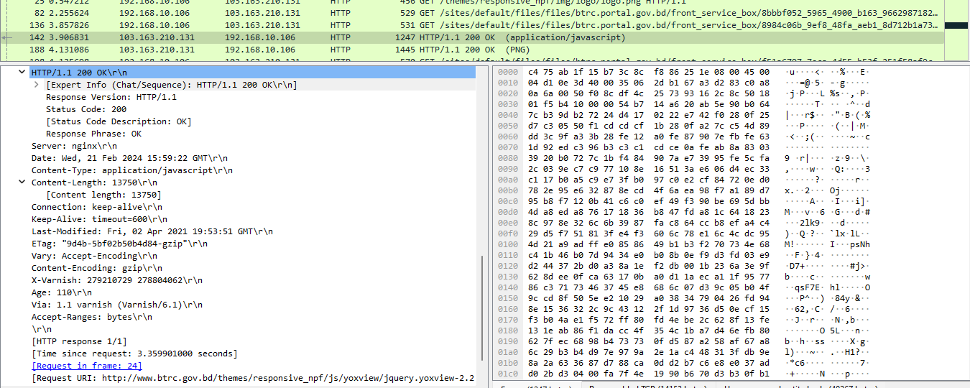

This application layer header has information such as: its’ HTTP response header; timeout for security purposes; content length of the data size; and last modification data made to the data on the server so that if the request is through a local DNS then can be tracked the updated data; acceptance ranges of data unit.

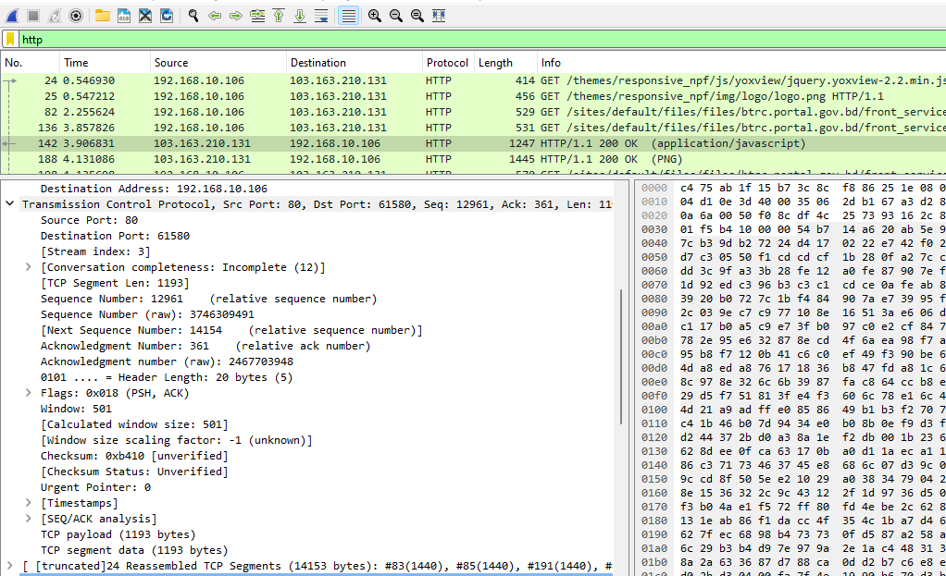

In the transport layer header, there is a source port set to 80 as data is sent from the server port to my port which is of the range -private port range. Sequence and ack number for the receiver to properly assemble the sent data using the seq number. PSH flag to send out the data and ACK sent for the prev request. There is checksum info of the TCP protocol for preventing data corruption and detecting it.

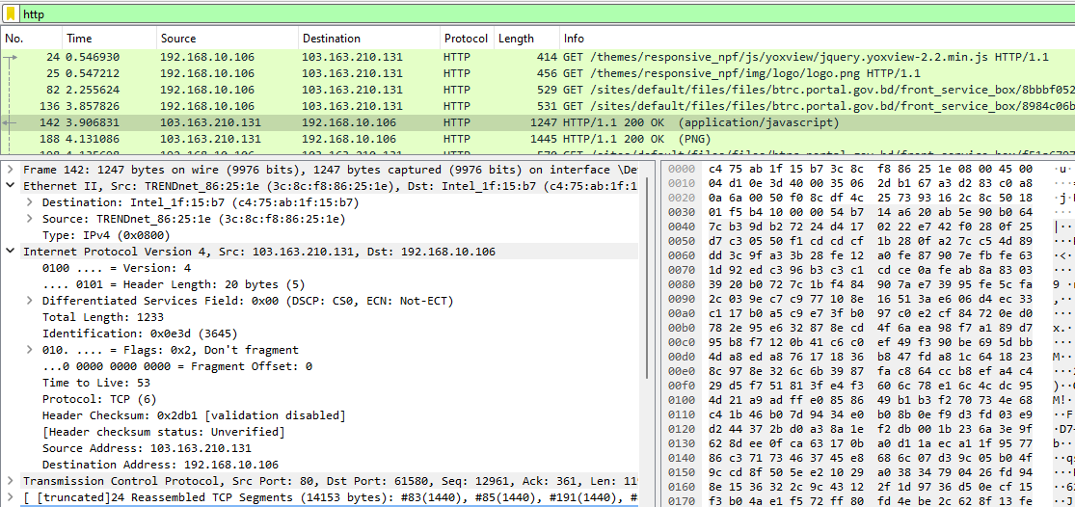

The network layer header uses the IPV4 protocol and has information such as source and destination IP address where the source IP is of the server and the destination IP is of mine.

The data link layer header has the MAC address of the source server and the destination MAC of the next hub.